Use Case Specification

DMT/RM01/TMP

|  |  |
| --- | --- |
| Project Code | PRO_MakeMyJourney_001 |
| Project Name | MAKE MY JOURNEY |

|  |  |  |
| --- | --- | --- |
| Prepared/Modified by | Role | Date of Preparation |
| Sabareeshwari B | Test Engineer | 6/27/2018 |
| Reviewed by | Role | Date of Review |
| Revathi | Test Lead |  |
| Approved by | Role | Date of Approval |
| Harri | Test Manager |  |
| Circulation List |  | Version Number of the template: |
| Version Number | 1 |  |

<<Customer>> REVIEW HISTORY

<<Customer comments on the Use case along with the signed off is tracked here>>

|  |  |  |  |  |  |  |
| --- | --- | --- | --- | --- | --- | --- |
| Version | <<Version number>> |  |  |  |  |  |
| Date | <<Date of Review>> |  |  |  |  |  |
| Reviewed by | << Reviewer Name>> |  |  |  |  |  |
| Reviewed UI Specification doc | << Whether UI Specification doc is reviewed >> |  |  |  |  |  |
| All Open Queries/issues closed | << Whether all the open queries and issues resolved>> |  |  |  |  |  |
| Agreement on Assumptions | <<Whether all the assumptions have been agreed upon by the customer>> |  |  |  |  |  |
| Sign Off | <<Signature>> |  |  |  |  |  |

Disclaimer:

The scope of the project ‘<<**MakeMy Journey**>>’ is restricted to the contents of this signed off use case.

TABLE OF CONTENTS

1.Use Case Name: <<Use Case Name>> 4

2.Actor(s) 4

3.Preconditions 4

4.Flow of Events 4

4.1 Basic Flow 4

4.2 Alternative Flows 5

4.2.1 Alternate Flow 1 5

4.3 Sub Flows 6

4.3.1 Sub Flow 1 6

5.Post Conditions 6

6.Special Requirements 7

7.Extension Points 7

<Name of extension point> 7

8.Business Rules 7

9.Diagrams 8

Use Case Diagram 8

Activity Diagram 9

10.Scenarios 10

Success Scenarios 10

Failure Scenarios 10

11.Issues 10

12.UI Specifications 10

13.Inter System Dependencies 11

14.Integration with an already existing System of the <<Customer>> 11

15.Assumptions 11

REVISION HISTORY OF THE WORK PRODUCT…………………………….. .. 12

Use Case Name: Make my journey user registration form

Use Case ID:MakeMyJourney_001

**Brief Description:** The provided usecase describes the process of registration of MakeMy Journey User Registration form.

Actor(s)

1. User

2. System.

Preconditions - Users

1. User after giving his user name needs to click on Check Availability for the availabity of user name.

2. User should give their security Ouestion and answer.

3. User has a valid user and active Email ID.

Flow of Events

4.1 Basic Flow

**Name:** Successful login.

1. User visits the MakeMyJourney URL [**http://www.makemyjourney.co.in**](http://www.makemyjourney.co.in) using any standard browser.
2. User enters his/her user name and checks the availability.
3. User gives the valid credentials for registration.
4. User clicks submit button.
5. On successful login, home page is displayed.

**Name:** Registration for MakeMyJourney

1. User visits link available on the Admin Home Page.
2. User sign up using this link.
3. User enters his/her user name and checks the availability
4. User enters security question and answer.
5. User enters first name
6. User enters last name.
7. User selects gender as male/female.
8. User enters date of birth.
9. User enters mobile number
10. User clicks on submit button.
11. System displays the message ”Thank You for registering” message for confirming the registration.

* 1. Alternative Flows

Alternate Flow 1: Successful registration to MakeMyJourney

**Name:** Registration for MakeMyJourney

1. User visits link available on the Admin Home Page.
2. User sign up using this link.
3. User enters his/her user name and checks the availability
4. User changes security question and answer.
5. User enters first name
6. User enters last name.
7. User selects gender as male/female.
8. User enters date of birth.
9. User enters mobile number
10. User clicks on submit button.
11. System displays the message ”Thank You for registering” message for confirming the registration.

Alternate Flow 2: Successful Exam Addition

**Name:** Registration for MakeMyJourney

1. User visits link available on the Admin Home Page.
2. User sign up using this link.
3. User enters his/her user name and checks the availability
4. User enters security question and answer.
5. User enters first name
6. User enters last name.
7. User selects gender as male/female.
8. User enters date of birth.
9. User changes mobile number.
10. User clicks on submit button.
11. System displays the message ”Thank You for registering” message for confirming the registration.

Exceptional Flow

Exceptional Flow 1: Unsuccessful Registration of MakeMyJourney

**Name:** Registration for MakeMyJourney

1. User visits link available on the Admin Home Page.
2. User sign up using this link.
3. User enters his/her user name.
4. User enters security question and answer.
5. User enters first name
6. User enters last name.
7. User selects gender as male/female.
8. User enters date of birth.
9. User enters invalid mobile number.
10. User clicks on submit button.
11. System displays the message ”Invalid Mobile number”.

Exceptional Flow 2: Unsuccessful Exam Addition due to invalid date

**Name:** Registration for MakeMyJourney

1. User visits link available on the Admin Home Page.
2. User sign up using this link.
3. User enters his/her user name as existing for registration.
4. User enters security question and answer.
5. User enters first name
6. User enters last name.
7. User selects gender as male/female.
8. User enters date of birth.
9. User enters mobile number.
10. User clicks on submit button.
11. System displays the message ”User name is not unique”.

Exception Flow 3: Web Server Down

**Name:** Registration for MakeMyJourney

1. User visits link available on the Admin Home Page.
2. User sign up using this link.
3. User enters his/her user name and checks the availability
4. User enters security question and answer.
5. User enters first name
6. User enters last name.
7. User selects gender as male/female.
8. User enters date of birth.
9. User enters mobile number
10. User clicks on submit button.
11. The system displays an error message regarding web server unavailability problem.

Exception Flow 4: Database Connectivity Error

**Name:** Registration for MakeMyJourney

1. User visits link available on the Admin Home Page.
2. User sign up using this link.
3. User enters his/her user name and checks the availability
4. User enters security question and answer.
5. User enters first name
6. User enters last name.
7. User selects gender as male/female.
8. User enters date of birth.
9. User enters mobile number.
10. User clicks on submit button.
11. The system displays an error message regarding database connectivity problem.

Exception Flow 5: Network Connectivity Error

**Name:** Registration for MakeMyJourney

1. User visits link available on the Admin Home Page.
2. User sign up using this link.
3. User enters his/her user name and checks the availability
4. User enters security question and answer.
5. User enters first name
6. User enters last name.
7. User selects gender as male/female.
8. User enters date of birth.
9. User enters mobile number.
10. User clicks on submit button.
11. The system displays an error message regarding network connectivity problem.

Post Conditions

| Flow Name | Post Condition |
| --- | --- |
| Successful registration to MakeMyJourney | System displays the message ”Thank You for registering” message for confirming the registration. |
| Unsuccessful registration to MakeMyjourney | System displays the message ”Invalid Mobile number”. |
| Unsuccessful registration to MakeMyjourney | System displays the message ”User name is not unique”. |
| Web Server Down | The system should display an error message to the user when web server faces problem |
| Database Connectivity Error | The system should display an error message to the user when the database connectivity is in problem |

Special Requirements

Performance

The user should receive the mails and sms after registration for MakeMyJourney.

Availability

* 1. Website is up and running 24*7.

Business Rules

| Business Rule Name | Business Rule Description | System action (if BR fails) |
| --- | --- | --- |
| BR01 | The sign up should be done using valid credentials | Error message is displayed if not valid |
| BR02 | The user names should be unique | Error message is displayed if same names are entered |

Diagrams

Use Case Diagram

* 1. For Successful Addition of Exam

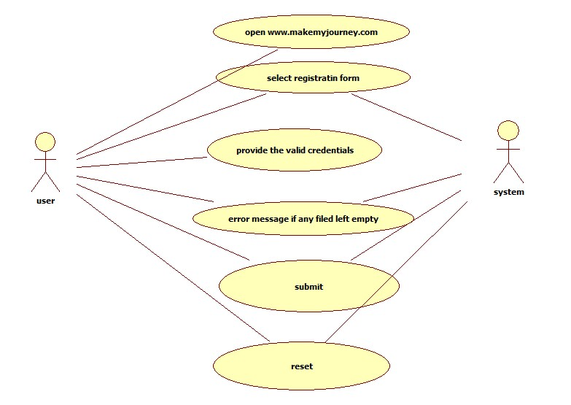

Scenarios

Success Scenarios

* Successful submission of Make MyJourney

Failure Scenarios

* Failed submission of due to leaving a field blank.
* Failed submission of due to entering wrong name
* Failed submission of Exam Application due to network error.

Issues

1. What is to be done if web server is down?
2. What is to be done if there is data connectivity error?

UI Specifications

Assumptions

1.Only user can avail this service.

REVISION HISTORY OF THE WORK PRODUCT

<to be maintained by projects>

|  |  |  |  |  |  |
| --- | --- | --- | --- | --- | --- |
| # | Date | Version # | Section Changed | Details of changes made | Approved By |
| 1 |  |  |  |  |  |
| 2 |  |  |  |  |  |